Lab 4:

1. Write SQL query to update data whose id is 1.

Source code:

UPDATE student4 SET

S_NAME = 'Sanjay Singh',

S_MARKS = 76,

S_GRADE = 11,

address = 'Lalitpur'

WHERE S_ROLL = 1;

Output:

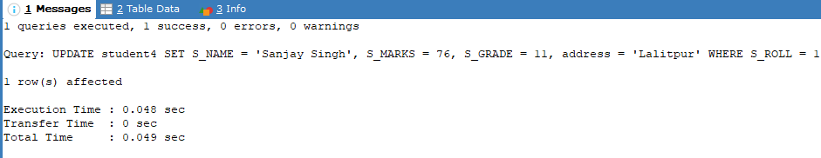

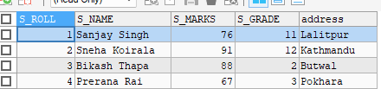

1. Write SQL code to change address into ‘london’ whose name is dilip.

Source code:

UPDATE student4 SET address = 'London' WHERE S_NAME = 'Dilip';

Output:

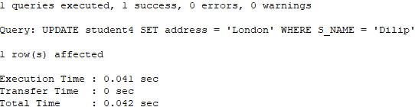



1. Write SQL code to modify name whose roll no is 7.

Source code:

UPDATE student4 SET S_NAME = 'Nishant Sharma' WHERE S_ROLL = 7;

Output:

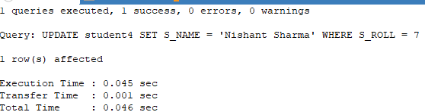



1. Write SQL code to display records from student table using aggregation function (SUM, MIN, MAX, AVG, COUNT).

Source code:

SELECT

SUM(S_MARKS) AS Total_Marks,

MIN(S_MARKS) AS Min_Marks,

MAX(S_MARKS) AS Max_Marks,

AVG(S_MARKS) AS Average_Marks,

COUNT(*) AS Total_Students

FROM student4;

Output:

